DATE: **April 11th, 2021**

TO: **Dr. Deirdre Hunter**

FROM: **Sindhuja Darisipudi, Nora Han, Joseph Urso, Michael Tang, Jason Ye[1]**

**Team Moonrats (**[**5moonrats@gmail.com**](mailto:5moonrats@gmail.com)**)**

SUBJECT: **Water Assessment Incubator Design Criteria**

**Introduction**

1. **Relevant Context for the Engineering Design Process**

Our client needs a 3M™ E. coli detection Petrifilm[2] incubator to provide a stable temperature environment for 24-48 hours. Currently, he has identified several problems with their existing incubator (“The Armadillo Incubator”) and has asked us to create an improved, low-cost and portable incubator for these Petrifilms that is suitable for water sanitation testing research in remote areas that lack lab resources.

According to our previous meeting with our client, we identified several potential design solution features of a portable, low-cost incubator to hold 20 small petri film (3x4 inches) which has: the ability to provide a constant elevated temperature; a data tracking and digital readout of temperature; rechargeable primary cells that could last the duration of one incubation cycle per one charging; be able to work with minimal repairs. If possible, we would like to have the following features: a warning mechanism to indicate if the system has failed, the battery is low, or if the temperature has fluctuated out of range; a humidity control inside of the incubator

1. **Overview of Decision Process & Reasons of Research decisions**

Our team generated a list of design criteria and constraints during class discussion (Feb, 9, 2021) and our weekly team meeting (Feb, 9, 2021). The constraints of our design criteria are mainly based on client requests and quantitative research. In some cases, the client has provided us with quantitative requirements, whose parameters agree with our additional research. The objectives are mainly based on client requests and will be evaluated by the users. Detailed explanations of each criteria are included in the conclusion section. We started by listing out the criteria without the numbers (low cost, small size, easy to make, easy to use, be in temperature range, battery life, durability, battery alarm, temperature alarm, data tracking system). Then, on the basis of our interview with our client (Feb, 5, 2021), we identified which criterias are constraints (be in temperature range, and safety) based on our need-to-know list and research in TM_2. Finally, we confirmed a reasonable list of design criteria (low cost, size, easy to make, easy to use, durability, battery duration and adjustable temperature).

In brief, our final design is a thermos with heat tape along the inside into which we place a shelf of petrifilms. The thermos will be used as the main source of insulation, the heat tape for heating, and the shelf to hold the petrifilms in place. Figure 1 below shows a CAD design of the final design, including its dimensions. It should be noted that the final design is not see-through, but the CAD design is see-through in order to see the elements inside of the container. Figure 2 shows the expanded view of the design and breaks down the design into its components.

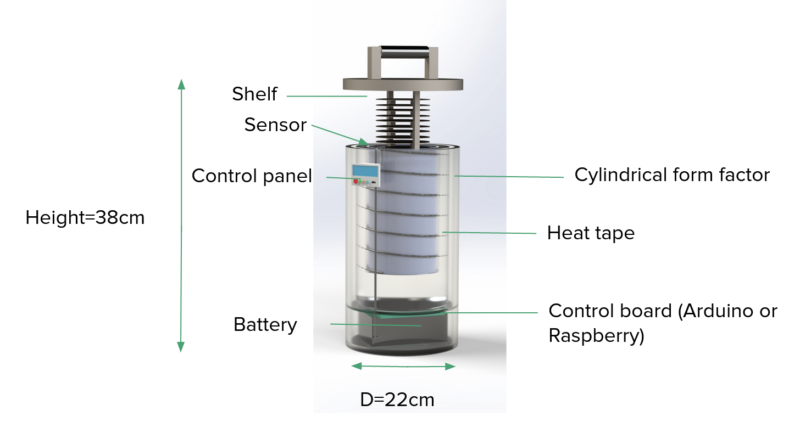

***Figure 1: CAD Design of Final Solution for Water Assessment Incubator***

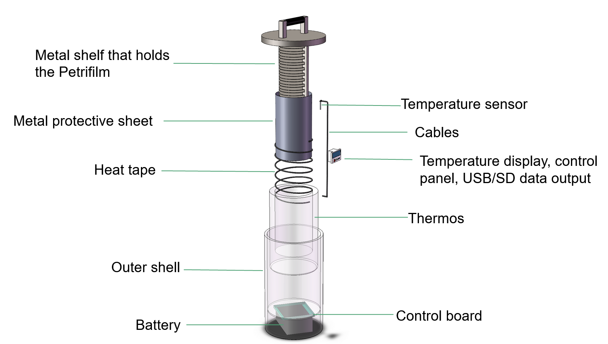

***Figure 2: Expanded CAD design of Water Assessment Incubator***

We also programmed on the microcontroller in order to link the microcontroller, heat tape, temperature sensor, and digital display. A schematic about the program that we used can be seen in Figure 3 below

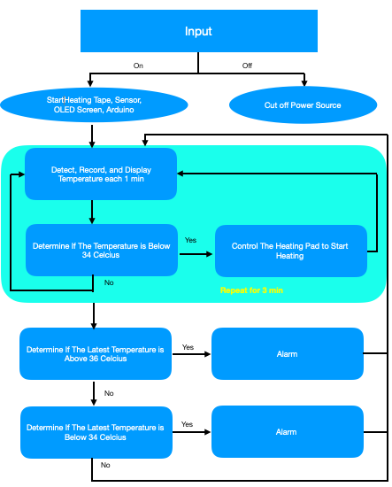

***Figure 3: Draft Flowchart For Medium Fidelity Prototype***

During the prototyping process, we made two major changes from our initial design. The first one being changing the temperature sensor from LM35 to DS18B20 for a more accurate temperature reading and the waterproof quality (April, 2nd, 2021). We consulted this source: <https://randomnerdtutorials.com/dht11-vs-dht22-vs-lm35-vs-ds18b20-vs-bme280-vs-bmp180/> for a professional opinion on the precision difference between LM35 and DS18B20 sensors. The second one is changing from Arduino Nano to Arduino Mega 2560 because of the limited RAM of Arduino Nano (April, 11th, 2021).

Right now, we have mostly finished the coding part of the incubator: the temperature control system, the temperature numerically (for every 5 seconds, not 1 min in the flow chart because we wanted to improve the accuracy) and the temperature line chart display (for the last 500 second), the alarm function (see the green loop in Figure 3), and the data logging function. The program still needs to be tested on Arduino Mega 2560 because Arduino Nano was not able to ideally run the codes. But we estimate that it would need little modification after we test it on Arduino Mega 2560. Below ***(Figure 4)*** is the electronic component part of our medium fidelity prototype built in one of our teammates’ home (we had to divide our tasks because one of our teammates, Nora, is remote this semester, and she is in charge of the coding part of this project. She purchased electronic components in Beijing).

;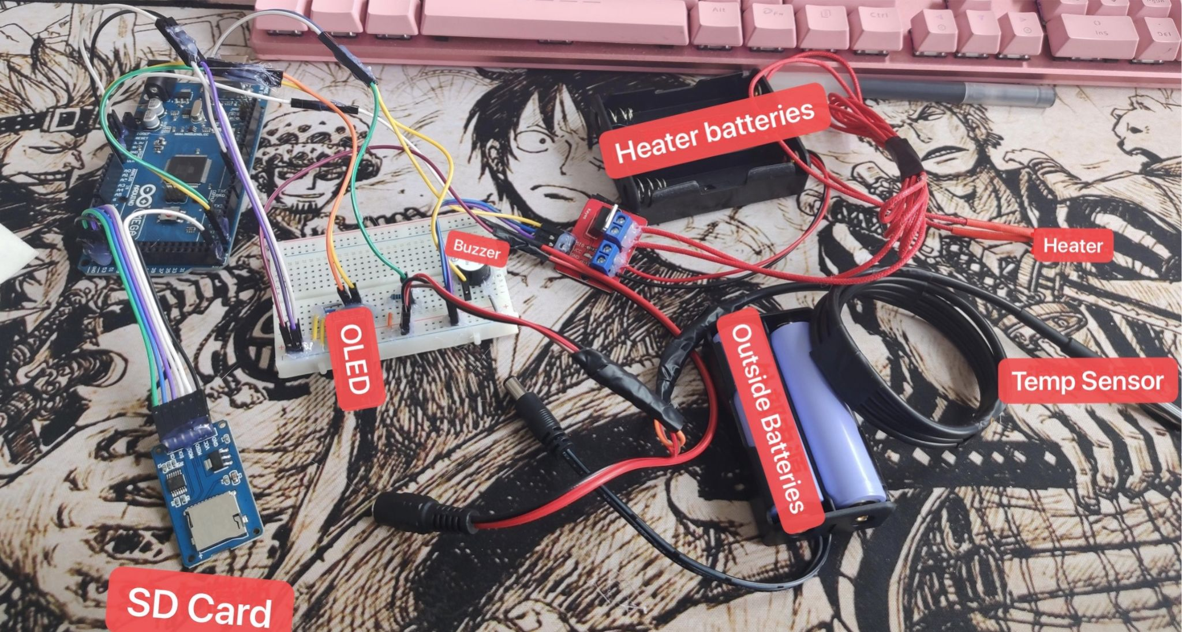

***Figure 4: Connected Electronic Components***

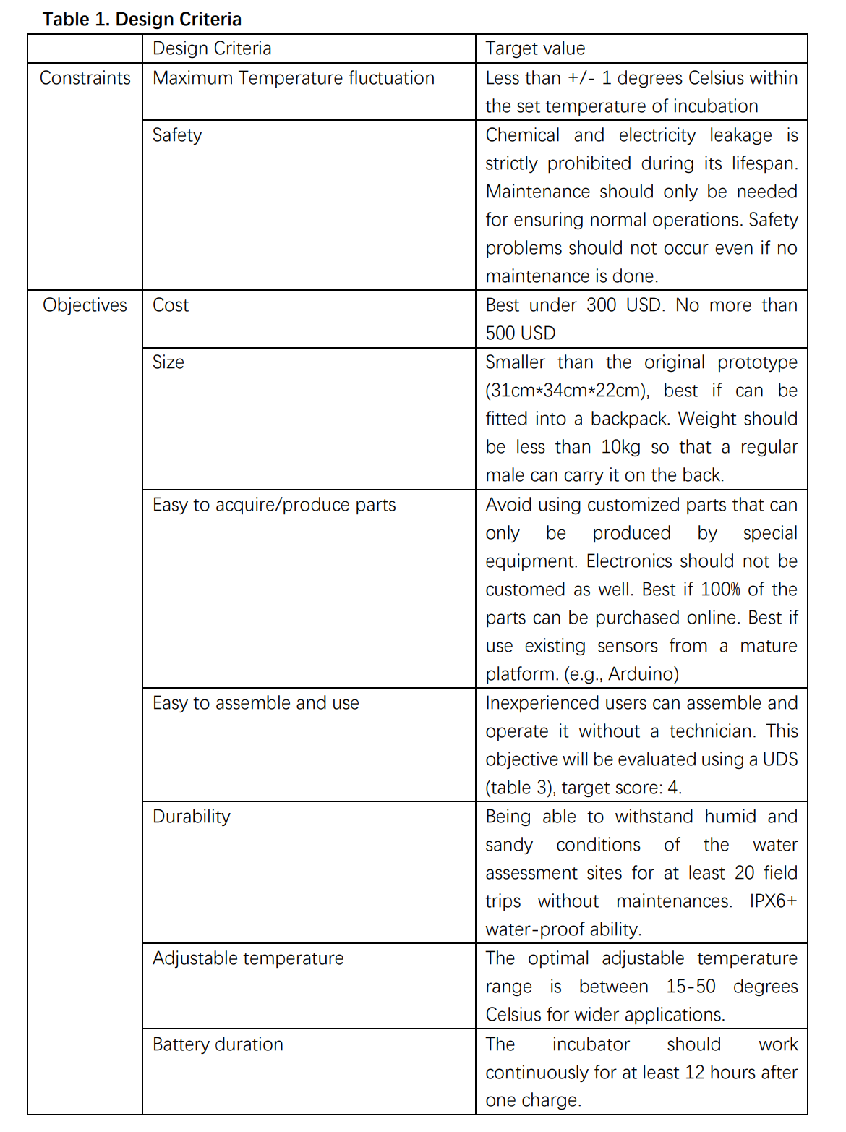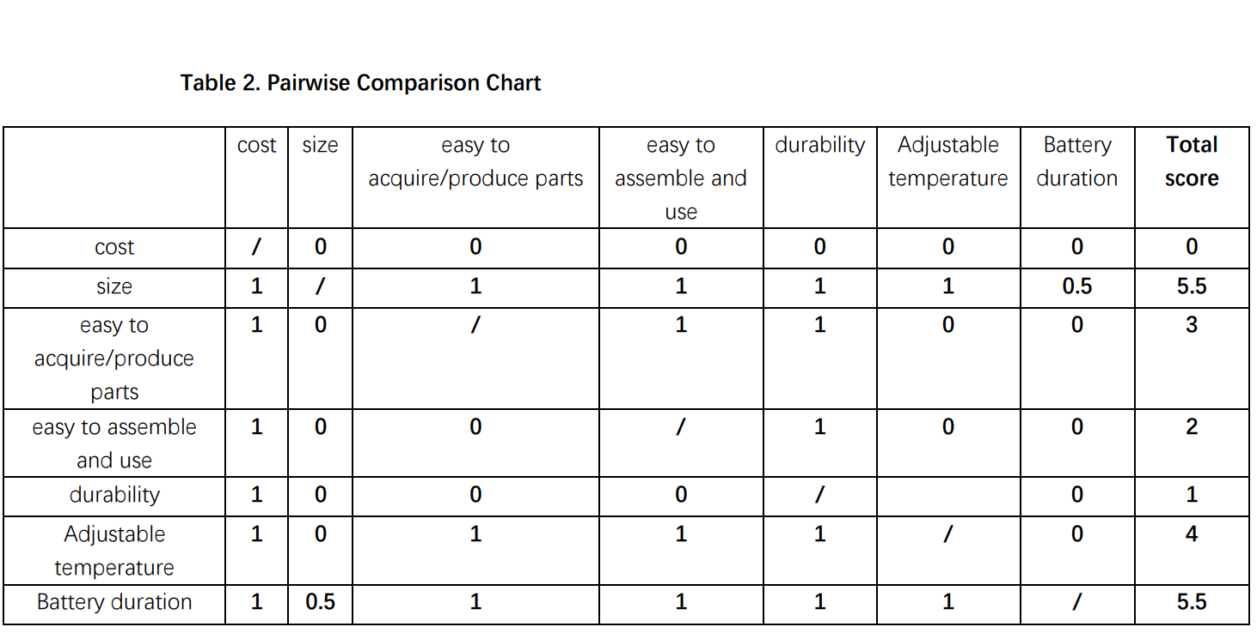

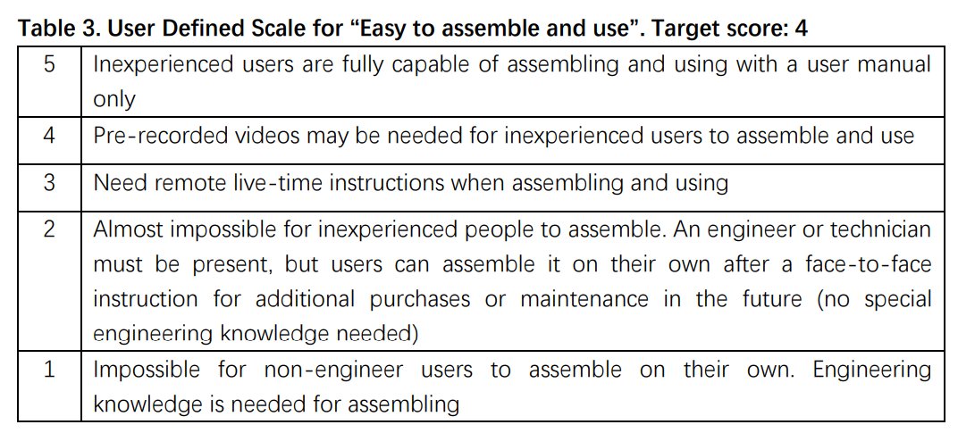

**Conclusion**

Detailed explanations of each design criteria in table 1 are shown below:

***Constraints:***

*1) Maximum allowed temperature fluctuation: +/- 1 degree Celsius*

We have set the maximum allowed temperature fluctuation to be +/- 1 degree Celsius based on the existing biological incubator models and the *user manual of a typical 3MTM Petrifilm*. Some existing models have a fluctuation of +/- 2 degrees Celsius, but the recommended temperature fluctuation of 3MTM Petrifilm from its user manual is +/- 1 degree Celsius. Since the client stated that the standard 3MTM Petrifilm will be used mostly in water assessment, we have set this constraint to meet the client requirement.

*2) Safety: 0 safety problem allowed during its lifespan*

Since the battery will likely be a massive one, a leakage of either its chemical contents or electricity can cause serious accidents. Also, if we use chemical reactions as a heating method, these chemicals can be harmful to the human body as well. Therefore, in order to ensure the safety of its users, we have set the constraint to be no leakage of any kind is allowed even if the incubator does not receive regular maintenance.

The objectives are mainly based on client requests. Based on the nature of some objectives, it is hard to quantify some of them. For these objectives, we will use a user defined scale to evaluate our design.

***Objectives:***

The relative importance of each objective is compared and calculated in table 2, pairwise comparison chart.

*1) Cost: cannot exceed 500 USD*

The cost should be under 300 USD if possible. However, based on additional features and smaller size, the client is willing to pay a maximum of 500 USD for one model.

*2) Size: must be smaller than the original prototype*

The size of the original prototype is 31cm*34cm*22cm. The minimum requirement is that our model cannot be bigger than the original prototype. It is preferred that the incubator can fit into a typical backpack. Therefore, our eventual goal is to make the incubator smaller than 30cm*25cm*15cm, approximately.

*3) Easy to acquire/produce parts*

Since water assessment is conducted mainly in suburban areas of developing or under-developed countries, sometimes it is hard to acquire customized parts, and biologists may not be familiar with mechanical components of the incubator. Therefore, we should use existing parts as much as possible, and try to avoid using parts that can only be manufactured by special equipment. The best case scenario is that 100% of the parts can be purchased online through some widely used shopping websites, such as Amazon, and no special tools other than basic electric tools (drills, electric saws) are needed.

*4) Easy to assemble and use*

Biologists are not engineers. They may not fully understand how the incubator works. Since they are the users, we should consider the user-friendliness of our product. They should be able to assemble and operate the incubator with only a user manual and potentially pre-recorded tutorial video and without the help of an engineer or technician on site. If we achieve this ultimate goal, we will receive a score of 4 on our UDS.

*5) Durability*

This incubator is not lab equipment. It needs to withstand the possibly severe environmental and weather conditions of the testing site and during transportation. We expect it to be at least better than IPX6, which means no water can pass through its outer shell under high-pressure, heavy-sprays of water.

*6) Adjustable temperature: 15-50 degrees Celsius*

The client requires the temperature of the incubation chamber to be adjustable in order to meet the incubation requirements of different germs, possibly further applications other than water assessment. From the data provided by *Biodiversity of Fungi and Separation Science and Technology*, the adjustable range between 15 and 50 degrees Celsius allows the incubation of most common germs.

*7) Battery duration: >=12 hours*

We have set the minimum battery duration after a single charge to be >= 12 hours. This is a client requirement. Additionally, according to the *Journal of Clinical Microbiology*, the Association for the Advancement of Medical Instrumentation recommends all cultures should be incubated for at least 12 hours(one cycle of incubation) on suitable culture media before further observation. Therefore, in order to guarantee the accuracy of further observation after incubation, and according to our client’s requirement, we decide to follow the above guidance.

The driving force of our design criteria is mostly a combination of client request and our research. The client has set many goals for us, in which we listed all of them in our design objectives. Since most of his requests are as brief as basic descriptions of the functions that are preferred to have, we also did our research to further quantify the target functions.

As for the most difficult part of constraints, we think that the battery duration will be our biggest challenge. We cannot make the battery smaller because of the limitations of modern-day battery technologies. The minimum duration of 48 hours will require a huge battery, which occupies a lot of precious space. Due to the huge size and limited capacity of battery, we will need to consider the layout of other components very carefully to minimize the size of our incubator. Also, we need to consider the method of heating and cooling if needed to maximize the energy efficiency.

The most difficult part of objectives is to minimize the size while making it easy to manufacture at the same time. We think that a very important and useful way of reducing the size is to use customized parts so that no space is wasted. We will discuss how to address this issue later.

Our team is working very efficiently. Everyone is highly motivated and is comfortable with expressing his/her insights during Zoom meetings both in and out of class time. The key to our productions of every tech memo is creating an equal and comfortable atmosphere of discussion and valuing everyone’s opinions. Our team is also driven by everyone’s passion and dedication into this project. The most memorable moment is that even during this hard time of blackout, everyone tried their best to contribute to this tech memo by attending meetings and researching useful materials.

Citation:

1. <https://www.3m.com/3M/en_US/company-us/all-3m-products/~/ECOLICT-3M-Petrifilm-E-coli-Coliform-Count-Plates/?N=5002385+3293785155&rt=rud>
2. <https://www.ncbi.nlm.nih.gov/pmc/articles/PMC270135/>
3. <https://www.sciencedirect.com/topics/immunology-and-microbiology/incubation-temperature>
4. <https://www.3m.com/3M/en_US/company-us/all-3m-products/~/ECOLICT-3M-Petrifilm-E-coli-Coliform-Count-Plates/?N=5002385+3293785155&rt=rud>

1. Main Writers: Nora Han and Jason Ye
2. See details at: https://www.3m.com/3M/en_US/company-us/all-3m-products/~/ECOLICT-3M-Petrifilm-E-coli-Coliform-Count-Plates/?N=5002385+3293785155&rt=rud